ARCON
PRODUCT STACK DEPENDENCY MATRIX
Product Stack Dependency Matrix
ARCON Secrets Management Platform
Version 10.11.005 — Release 01 June 2026
Product Name | ARCON Converged Identity
Product Version | v10.11.005
Release Date | 01 June 2026
Document Version | V1.2 (reformatted)
Document Status | For review and release readiness
Author | Deepali Mathur
Owner | Product Management

Contents

1. Purpose and Audience
2. Executive Summary
3. Technology Architecture
4. Component and Dependency Inventory
5. Supported Versions and End-of-Life Matrix
6. Platform Lifecycle and Compatibility
7. Risk Assessment
8. Recommended Actions and Ownership

1. Purpose and Audience
This document consolidates the technology stack supporting ARCON Secrets Management Platform v10.11.005. It maps direct and shared dependencies, highlights lifecycle and compatibility risks, and defines the actions needed to maintain release readiness, security compliance, and product supportability.
Three teams use this matrix, each for different purposes:
Audience | What the document gives you | Focus sections
Product Team  Development Team  Support & Implementation Teams | A risk picture to govern: themes to include in the release baseline, named ownership, release gates and the modernization roadmap. | 2 · 7 · 8
 | The exact component inventory, versions and end-of-life dates that set compatibility and build constraints. | 3 · 4 · 5
 | The lifecycle, platform and integration support matrices used for deployment, sizing and customer upgrade planning. | 5 · 6 · 8.3

2. Executive Summary
The release combines legacy and modern runtimes, multiple data platforms, access utilities, and shared open-source libraries. The principal product risks are concentrated in shared cryptographic and compression libraries, the continued use of .NET Framework 4.7.2, and compatibility dependencies across Java-based, database, messaging, and remote-access components. Product Management should govern these risks through an approved compatibility baseline, named ownership, evidence-based release gates, and a time-bound modernization roadmap.

2.1 Stack at a glance
- A deliberate mix of legacy (.NET Framework 4.7.2) and modern (.NET 8.0.22) runtimes ensures backward compatibility.Core runtime:
- Angular 14 powers the UI layer, dependent on RxJS, Zone.js, and TypeScript.Frontend:
- Apache Kafka and Redis provide real-time streaming and caching capabilities.Middleware & messaging:
- SQL Server, MySQL, and Apache Ignite form a hybrid data layer supporting transactional and distributed workloads.Databases:
- PuTTY, OpenSSH, FreeRDP and Apache Guacamole provide secure remote access and gateway functions.Access & connectivity:
- Squid acts as a proxy layer, enforcing traffic and access policies.Networking:
- OpenSSL and zlib remain critical across multiple layers — key for encryption and compression.Shared dependencies:
This stack integrates enterprise-grade Microsoft technologies with open-source distributed and streaming frameworks (Kafka, Ignite, Redis). Dependency hotspots include OpenSSL/zlib, the Java runtime, and .NET runtimes, which should be prioritized for patch management and compatibility validation.

3. Technology Architecture

3.1 Architecture diagram
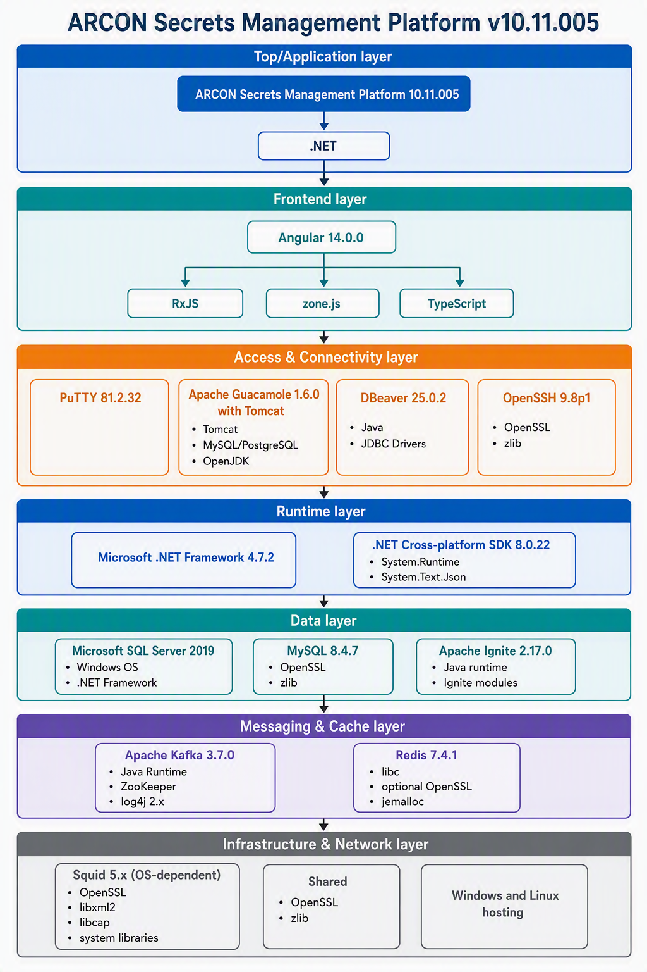
Figure 1 — ARCON Secrets Management Platform technology architecture

3.2 Technology layers
The architecture is layered from the top application surface down to infrastructure. Each layer is color-coded in the diagram and connected by downward arrows to show dependency flow.
Layer | Key components
Application | ARCON Secrets Management Platform (core application)
Frontend | Angular 14 with RxJS, Zone.js, TypeScript
Access tools | PuTTY, Apache Guacamole, DBeaver
Database layer | MS SQL Server 2019, MySQL 8.4.x, Apache Ignite
Messaging & cache | Apache Kafka and Redis for streaming and in-memory operations
Middleware & runtime | .NET Framework 4.7.2, .NET SDK 8.0, Apache Tomcat, OpenSSH
Infrastructure | Squid Proxy, OpenSSL & zlib, Linux & Windows servers

4. Component and Dependency Inventory
The authoritative inventory of components, versions, suppliers and direct dependencies.
Component | Version | Supplier | Type | Dependencies
ARCON Secrets Management Platform | 10.11.005 | ARCON TechSolutions Pvt. Ltd. | Application | .NET
Microsoft .NET Framework | 4.7.2 | Microsoft Corporation | Framework / Runtime | None
.NET (Cross-platform SDK) | 8.0.22 | Microsoft Corporation | Framework | System.Runtime; System.Text.Json
Angular | 14.0.0 | Google LLC | Frontend Framework | RxJS; Zone.js; TypeScript
DBeaver | 25.0.2 | DBeaver Corporation | Application | Java; JDBC Drivers
PuTTY | 81.2.32 | Simon Tatham | Application | None
Apache Guacamole | 1.6.0 | Apache Foundation | Web Application | Tomcat; MySQL/PostgreSQL; OpenJDK
OpenSSH | 9.8p1 | The OpenBSD Project | Library / Application | OpenSSL; zlib
Microsoft SQL Server | 2019 | Microsoft Corporation | Database Server | Windows OS; .NET Framework
MySQL | 8.4.7 | Oracle Corporation | Database Server | OpenSSL; zlib
Squid | 5.x (OS-dependent) | Squid Software Foundation | Proxy Server | OpenSSL; libxml2; libcap; system libraries
Apache Ignite | 2.17.0 | Apache Software Foundation | Distributed DB / Compute | Java runtime; Ignite modules
Apache Kafka | 3.7.0 | Apache Software Foundation | Event Streaming Platform | Java Runtime; Zookeeper; log4j 2.x
Redis | 7.4.1 | Redis Labs | In-memory DB / Cache | libc; openssl (optional); jemalloc

5. Supported Versions and End-of-Life Matrix
Versions the platform ships with or is compatible with, alongside end-of-life commitments. EOL dates are as published by each vendor and should be re-verified before every release.
Component | Currently Supported Versions | End of Life / End of Support
.NET Framework | 4.8.1 | Indefinite (tied to Windows OS lifecycle)
.NET Framework | 4.8 | Indefinite (tied to Windows OS lifecycle)
.NET Framework | 4.7.2 / 4.7.1 / 4.7 | Indefinite (tied to Windows OS lifecycle)
.NET Framework | 4.6.2 | End of support: January 12, 2027
.NET Framework | 3.5 SP1 | End of support: January 9, 2029
.NET (Cross-platform SDK) | .NET 10 (LTS) | End of support: November 14, 2028
.NET (Cross-platform SDK) | .NET 9 (STS) | End of support: November 10, 2026
.NET (Cross-platform SDK) | .NET 8 (LTS) | End of support: November 10, 2026
Angular | Angular 22 | End of support: June 30, 2028
Angular | Angular 21 | End of support: June 30, 2027
Angular | Angular 20 | End of support: November 28, 2026
DBeaver | 26.x (latest stable: 26.2.0) | Rolling release — only the latest minor version receives active security patches.
PuTTY | 0.85 (latest stable) | Legacy versions are superseded immediately upon a new security release.
Apache Guacamole | 1.6.x (latest stable: 1.6.0) | Fully backward compatible across 1.x releases; updates apply forward to the newest stream.
OpenSSH | 10.x (latest stable: 10.5) | Upstream rolling support; long-term support inherited from the OS lifecycle (e.g. Ubuntu, RHEL).
OpenSSH | Older versions packaged via Linux distros | Upstream rolling support; long-term support inherited from the OS lifecycle.
Microsoft SQL Server | SQL Server 2022 | Extended Support until January 11, 2033
Microsoft SQL Server | SQL Server 2019 | Extended Support until January 8, 2030
Microsoft SQL Server | SQL Server 2017 | Extended Support until October 12, 2027
Note: SQL Server 2016 reached final EOL on July 14, 2026.
MySQL | 9.x (Innovation) | Rolling — superseded quarterly
MySQL | 8.4 LTS | Premier Support until April 2029
Note: MySQL 8.0 reached official EOL in April 2026.
Squid | 6.x / 5.x branches | Rolling support via operating-system backports or the latest major branch.
Apache Reverse Proxy (Apache HTTP Server) | Apache 2.4.x | Active — no EOL date announced yet.
Note: Version 2.2.x reached EOL on July 11, 2017.
NGINX Reverse Proxy (Open Source) | 1.31.x (Mainline) | Active
NGINX Reverse Proxy (Open Source) | 1.28.x / 1.29.x (Stable) | Active
Note: Legacy branches 1.27 and earlier are EOL.
FreeRDP | FreeRDP 3.x (latest: 3.31.x) | Active — rolling community support.
Note: FreeRDP 2.x and below are no longer actively maintained.

6. Platform Lifecycle and Compatibility

6.1 Operating systems
OS | Version | Support status | Key lifecycle milestones
Windows Server | 2019 | Supported (Extended) | Mainstream support ended January 2024; security-only patches until January 9, 2029.
Windows Server | 2022 | Supported | Mainstream support ends October 13, 2026, then security-only updates until October 14, 2031.
RHEL | 8.x | Supported (Maintenance) | Full support ended May 2024; final minor release (8.10) receives security/bug maintenance until May 31, 2029.
RHEL | 9.x | Supported | Active Full Support until May 31, 2027, then Maintenance Support until May 31, 2032.
Ubuntu Server | 22.04 LTS | Supported | Standard public security updates until April 2027; ESM available through April 2032.

6.2 Browser support
Browser | Supported versions
Google Chrome | Latest 3 versions
Microsoft Edge | Latest 3 versions
Safari | Latest version

6.3 Identity sources
Component | Supported versions
Microsoft Active Directory | 2016, 2019, 2022
Azure AD / Entra ID | Supported
OpenLDAP | 2.5.x, 2.6.x
Okta | Supported
PingFederate | Supported

6.4 MFA integrations
Component | Supported
Microsoft Authenticator | Yes
Google Authenticator | Yes
RSA SecurID | Yes
Duo Security | Yes
FIDO2 Security Keys | Yes

7. Risk Assessment

7.1 Risk score heatmap
The heatmap layers the architecture with color-coded risk zones. Scores weight lifecycle position, shared blast radius, and the availability of active support.
Risk level | Score | Components in scope | Rationale
High | 5 | OpenSSL · zlib | Shared cryptographic and compression libraries used across the Infrastructure, Middleware and Database layers.
Medium | 4 | .NET Framework 4.7.2 · SQL Server 2019 · MySQL 8.4.7 · Apache Ignite · OpenSSH | Legacy runtime or lifecycle-constrained components.
Low–Medium | 3 | Access tools (PuTTY, Apache Guacamole, DBeaver) · ARCON Secrets Management Platform | Application and access-tool layer.
Low | 2 | Frontend (Angular 14, RxJS, Zone.js, TypeScript) · Apache Kafka · Redis | Components with active patch support.

7.2 Top 3 risk priorities
# | Priority | Rating | Why it matters | Action
1 | OpenSSL & zlib | High (5) | Shared across Infrastructure, Middleware and Database layers — any CVE affects multiple components simultaneously. | Continuous CVE monitoring and immediate patch rollout.
2 | Legacy .NET Framework 4.7.2 | Medium (4) | Limited support — security patches only. A dependency for the core application and SQL Server. | Plan migration to .NET 8 SDK; enforce patch compliance.
3 | Database & messaging engines | Medium (4) | SQL Server, MySQL, Apache Ignite, Kafka, Redis — depend on OpenSSL and the Java Runtime. | Apply cumulative updates and vendor advisories; harden configurations.

8. Recommended Actions and Ownership

8.1 Governance — Product Management
- Approve and maintain a compatibility baseline for this release, refreshed at each release cadence.
- Assign named ownership for the shared libraries that cross multiple layers.
- Gate each release on evidence: patch status, EOL proximity, and compatibility validation of each listed component.
- Own and track a time-bound modernization roadmap — the headline item being .NET Framework 4.7.2 to a supported modern runtime.

8.2 Engineering
- Prioritize patching and monitoring for shared encryption and compression libraries (OpenSSL, zlib) and the .NET and Java runtimes.
- Validate compatibility for every LTS/STS change of the runtimes, SDKs, and dependency framework versions listed in Section 5.
- Enforce lifecycle, compatibility, and hardening controls for database, messaging, cache, and remote-access components.

8.3 Support & Implementation — strategic suggestions
- consider adding Windows Server 2025 as the “Recommended” version for new deployments to maximize OS lifespan.Windows:
- TLS 1.2 is currently supported; support for TLS 1.3 must be included in the roadmap.TLS:
- consider validating or adding Ubuntu Server 24.04 LTS as a newer “Recommended” tier — 22.04 LTS nears the end of its 5-year standard support window next year.Ubuntu:
These measures address the most significant sources of systemic vulnerability and release disruption across the Secrets Management stack.

